**Generating Your Bot Token Step-by-Step**

**1. Go to the Discord Developer Portal**

Your first step is to browse over to the Discord Developer Portal: <https://discordapp.com/developers/applications/>

This portal shows all of your applications and bots.

If you already have a bot created, click it in the list. If you don’t have any discord bots, click the “New Application” button.

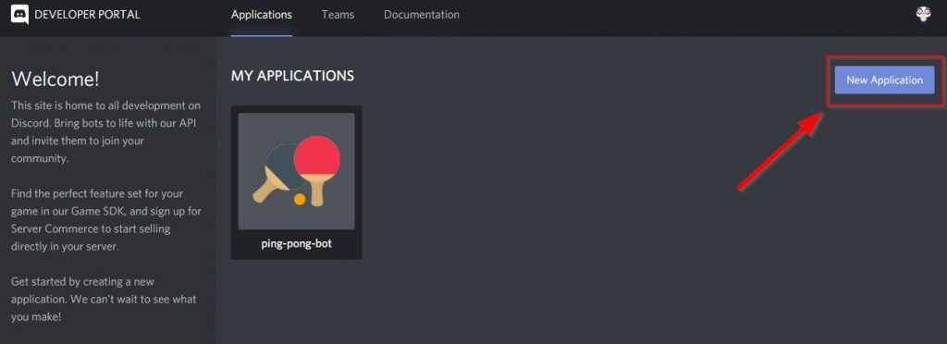

### ****2. Give Your Bot a Name****

Here you’ll be prompted to give your application (bot) a name.

You’re likely making a Discord Bot here, or you need your token for a Discord Bot. If this is true, then think about what you want your bot to be named and enter it here.

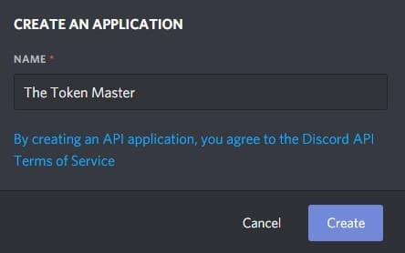

### ****3. Bring Your Bot to Life****  with an Icon and Description

Awesome! You’ve created your very first Discord Application! The only thing left is to bring your bot to life by giving it a description and an icon…

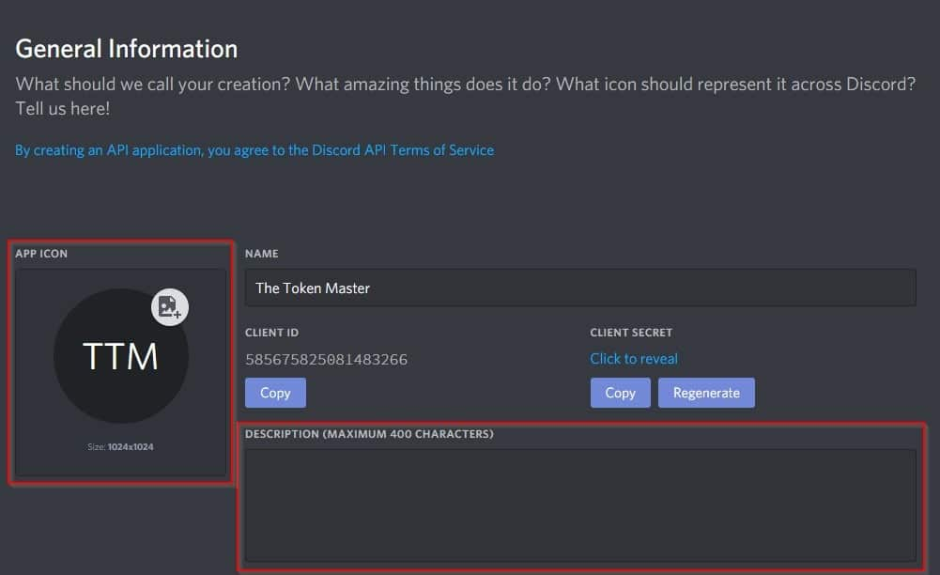

The best size for your bot’s icon is 1024×1024 pixels, but you can go lower and achieve quality results. I personally go with 512×512 most of the time (based on the icons I choose).

4. Set redirects

Your next step is to go over the menu on the left side of the screen and click “OAuth2. Clicked blue Button Add Redirect and paste in input field.

<https://discord.com/oauth2/authorize> saved it.

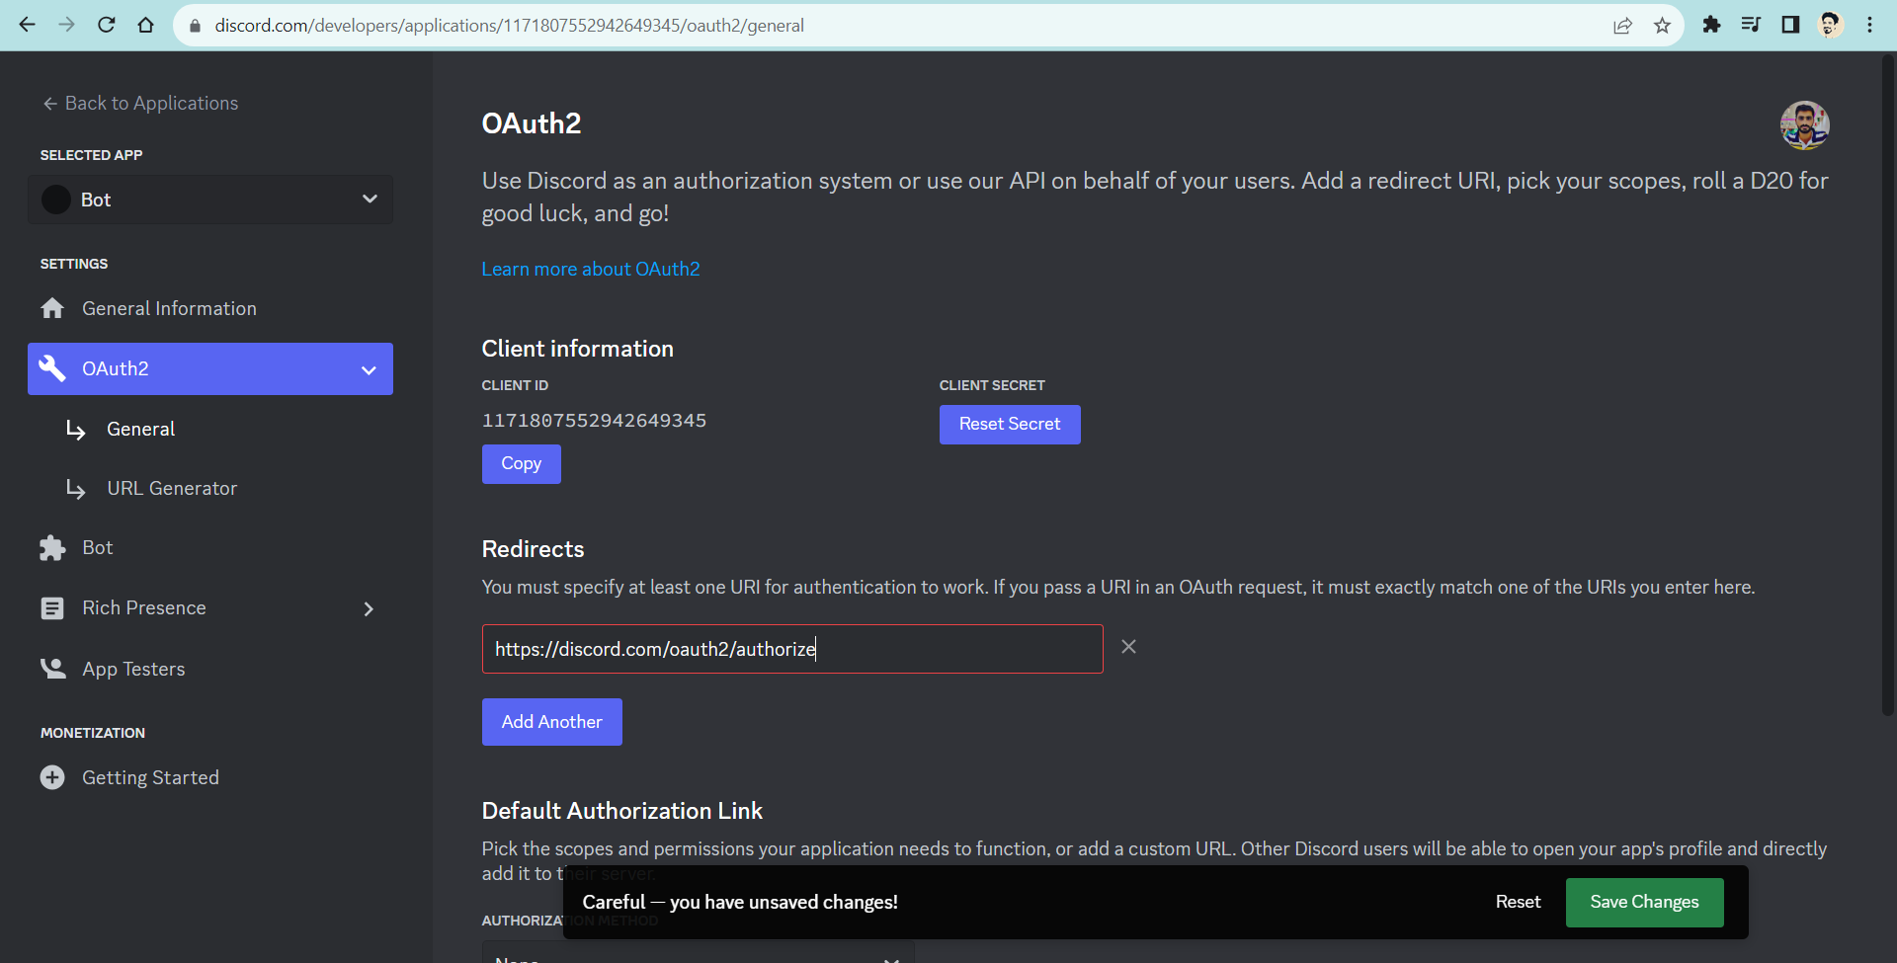

### **5. Url Generator**

### **Clicked the URL Generator, submenu of OAuth2 and select bot from scopes.**

### **After check the bot, check the Administrator from BOT PERMISSIONS box.**

### 

### **After that copied from GENERATED URL.**

### 

Click the blue “Copy” button on the right side. This is the URL you’ll navigate to in order to add your bot to a server.

Go to that URL and you’ll see a page that looks sort of like this (see below). Here you’ll want to select the server you’re adding your bot to, double-check the permissions you’re giving your bot, and then continue to the next step.

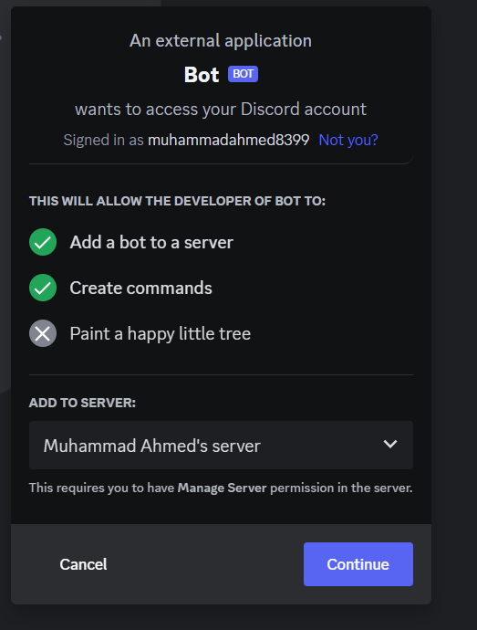

### **Select the server from here and clicked Continue**

### 

### **This timed clicked Authorize button.**

### You’ll likely get an “I’m not a robot” captcha message on the next screen. Solve the captcha and continue.

### 

### Success! Your bot has been authorized, and you should see it pop up in the list of participants on your server!

### ****4. Retrieve Your Token****

Your next step is to go over the menu on the left side of the screen and click “Bot”. It’s the icon that looks like a little puzzle piece.

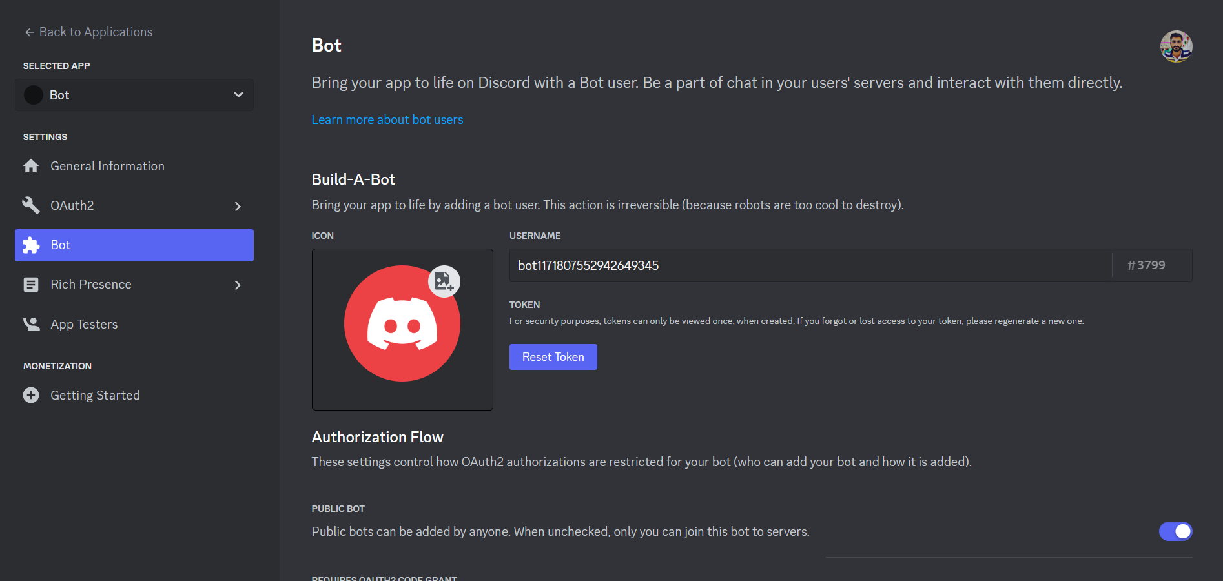

Clicked Reset Token Button. Now copy the Bot Token and also set the Bot name in the USERNAME input field

